

**CSCE 4613/5613: Introduction to Artificial Intelligence**

# Homework Assignment #4

**Submission Deadline**: 11:59PM, 11/18/2024

**Instruction:**

* This homework contains 4 questions. Note that the question 4(c) is **required** for **graduate** student.
* **What to submit:** A single pdf file contains your solution and your name. The filename should be

LASTNAME_FIRSTNAME_homework4.pdf

* You can discuss with your classmates, but **do not copy** each other work.

## Problem 1: [15 pts]

(1.1) Which of the following statements is equivalent to ¬∃*x*(*P*(*x*) ∧ *Q*(*x*)) (5pt)

* (a) ∀*x*(¬*P*(*x*) ∨ ¬*Q*(*x*))
* (b) ∀*x*(*P*(*x*) → *Q*(*x*))
* (c) ∃*x*(*P*(*x*) → ¬*Q*(*x*))

(1.2) What does the formula ∃*x*∀*y,R*(*x,y*) mean? (5 pts)

* (a) There exists an *x* such that *R*(*x,y*) is true for all *y*.
* (b) For all *x*, there exists a *y* such as *R*(*x,y*) is true.
* (c) For every pair (x,y), R(x,y) is true.

(1.3) Suppose every student enrolls at least one course. Define:

Student(s): s is a student

Course (c): c is a course

Enroll(s, c): s enroll c

Express this relationship in First-Order Logic. (5 pts)

∀*s*(Student(*s*)→∃*c*(Course(*c*)∧Enroll(*s*,*c*)))

## Problem 2: [40 pts]

Given 9 random variables, Bayesian Network in shown in figure 1.

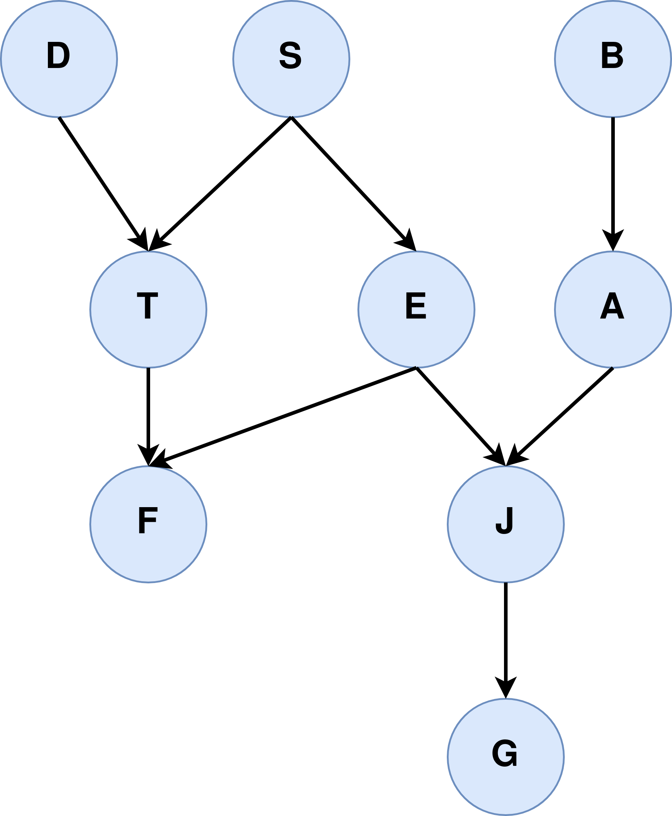

Figure 1: Bayesian Network

Please answer **True** or **False** to the following questions:

|  |  |
| --- | --- |
| 1. *P*(*D*|*S*) = *P*(*D*) TRUE 2. *P*(*D*|*S,T*) = *P*(*D*|*T*) TRUE 3. *P*(*D*|*S,E*) = *P*(*D*) TRUE 4. *P*(*D*|*S,F,E*) = *P*(*D*|*S*) FALSE 5. *P*(*T*|*J*) = *P*(*T*) TRUE 6. *P*(*T*|*J,E*) = *P*(*T*|*E*) TRUE 7. *P*(*T*|*J,E,F*) = *P*(*T*|*E,F*) TRUE 8. *P*(*F*|*J*) = *P*(*F*) FALSE 9. *P*(*F*|*J,T*) = *P*(*F*|*T*) FALSE 10. *P*(*F*|*J,E,G*) = *P*(*F*|*E*) | 1. *P*(*F*|*J,S*) = *P*(*F*|*S*) FALSE 2. *P*(*F*|*G,D,T*) = *P*(*F*|*G*) FALSE 3. *P*(*E*|*B,A,J,F,D*) = *P*(*E*|*B,A,J,F*) TRUE 4. *P*(*E*|*B,A*) = *P*(*E*|*B*) TRUE 5. *P*(*G*|*F,S*) = *P*(*G*|*F*) FALSE 6. *P*(*G*|*T,F*) = *P*(*G*|*F*) TRUE 7. *P*(*S*|*B,G,F*) = *P*(*S*|*B*) FALSE 8. *P*(*S*|*B,G*) = *P*(*S*|*G*) TRUE 9. *P*(*G*|*D,S*) = *P*(*G*|*S*) TRUE 10. *P*(*D*|*E,S,T,F*) = *P*(*D*|*T,F*) TRUE |

## Problem 3: [20 pts]

1. We flip a coin for many times and find that head appears twice as frequently as tail. What is the probability the coin flips head?
   1. **2/3 or 66.667%**
2. There are 3 winning tickets for every 100 tickets produced. If we buy 100 tickets, what is the probability that we have 2 winning tickets?
   1. Approximately **22.52%**
3. Kevin goes to AI class late 60% of the time, early 30% of the time and not showing up 10%. He wears Hog shirt 80% of the time he goes to the class late, 40% of the time he goes to the class early, 30% of the time he does not show up. What is the probability Kevin wears Hog shirt?
   1. 63%
4. Fill in the table below

|  |  |  |  |  |  |  |  |  |
| --- | --- | --- | --- | --- | --- | --- | --- | --- |
| **A** | **B** | **C** | **P(A,B,C)** | **P(C)** | **P(A,B)** | **P**(**A***,***B**|**C**) | **P**(**A**|**C**) | **P**(**C**|**B**) |
| 1 | 1 | 1 | 0.1 | 0.47 | 0.25 | 0.213 | 0.468 | 0.431 |
| 1 | 1 | 2 | 0.15 | 0.53 | 0.25 | 0.283 | 0.472 | 0.569 |
| 1 | 2 | 1 | 0.12 | 0.47 | 0.22 | 0.255 | 0.468 | 0.524 |
| 1 | 2 | 2 | 0.1 | 0.53 | 0.22 | 0.189 | 0.472 | 0.476 |
| 2 | 1 | 1 | 0.15 | 0.47 | 0.33 | 0.319 | 0.532 | 0.431 |
| 2 | 1 | 2 | 0.18 | 0.53 | 0.33 | 0.340 | 0.528 | 0.569 |
| 2 | 2 | 1 | 0.1 | 0.47 | 0.2 | 0.213 | 0.532 | 0.524 |
| 2 | 2 | 2 | 0.1 | 0.53 | 0.2 | 0.189 | 0.528 | 0.476 |

## Problem 4: [Undergraduate: 25 pts; Graduate: 35 pts]

Assume you are working at a manufacturer that produces billion computer chips every year. The company decides to buy another machine to boost the production rate, and they want you to lead the quality control team to assess the machine. Your team sends you the report of 100,000 chips they assessed. Out of 100,000 chips, they found 10,000 bad chips and 90,000 good chips. The width of the assessed chips are also reported.

|  |  |  |  |  |  |  |  |
| --- | --- | --- | --- | --- | --- | --- | --- |
| **Width** | 0.94cm | 0.96cm | 0.98cm | 1.00cm | 1.02cm | 1.04cm | **Total** |
| **Good** | 20,000 | 40,000 | 15,000 | 10,000 | 2,500 | 2,500 | **90,000** |
| **Bad** | 250 | 500 | 750 | 1000 | 5000 | 2,500 | **10,000** |
| **Total** |  |  |  |  |  |  | **100,000** |

Table 1: Report of the assessed chips

1. (15 pts) You wish to convert the table above into probability, whose value is in the range from 0 to 1. We denote
   * W as the random variable representing the width of the chip. The possible values of W are {0.94, 0.96, 0.98, 1.00, 1.02, 1.04}
   * S as the random variable representing the state of the chip. The possible values of S are {Good, Bad}
   1. Given a random chip, what is the probability that it is bad or *P*(*S* = Bad)?
      1. 10000/100000 = 0.1 or 10%
   2. Given a random chip, what is the probability that it is bad or *P*(*S* = Good)?
      1. 90000/100000 = 0.9 or 90%
   3. Given a good chip, what is the probability that its width is 0.96 or *P*(*W* = 0*.*96|*S* = Good)?
      1. 0.4/0.9 = 0.444 or 44.4%
   4. Given a bad chip, what is the probability that its width is 1.02 or *P*(*W* = 1*.*02|*S* = Bad)?
      1. 5000/100000 = 0.05
      2. P(S = Bad) = 0.1
      3. 0.05/0.1 = 0.5 or 50%
   5. What is the probability of having a good chip and its width is 0.96 or *P*(*W* = 0*.*96*,S* = Good)
      1. 40000/100000 = 0.4 or 40%
   6. What is the probability of having a bad chip and its width is 1.02 or *P*(*W* = 1*.*02*,S* = Bad)
      1. 5000/100000 = 0.05 or 5%
   7. Fill in the table below

|  |  |  |  |  |  |  |
| --- | --- | --- | --- | --- | --- | --- |
| W | 0.94cm | 0.96cm | 0.98cm | 1.00cm | 1.02cm | 1.04cm |
| *P*(*w*|*S* = Good) | 0.22 | 0.44 | 0.167 | 0.11 | 0.028 | 0.028 |
| *P*(*w S* = Bad) | 0.0025 | 0.005 | 0.0075 | 0.01 | 0.05 | 0.025 |

|

Table 2: Likelihood table

1. (10 pts) By now, you can see this machine is not perfect as it produces some bad chips. You decide to use Maximum Likelihood algorithm to detect whether a chip is good or bad by measuring its width. The Maximum Likelihood decision rule in this problem is described as:

*δML*(*w*) = argmax*P*(*w*|*s*) *s*∈*S*

With the decision rule above, fill in the table below:

|  |  |  |  |  |  |  |
| --- | --- | --- | --- | --- | --- | --- |
| W | 0.94cm | 0.96cm | 0.98cm | 1.00cm | 1.02cm | 1.04cm |
| *δML*(*w*) | Good | Good | Good | Good | Bad | Bad |

1. (10 pts) Maximum Likelihood can be used when the prior information is not given or in the case of uniform prior distribution. However, we do have the prior information, i.e. *P*(*S* = Good) and *P*(*S* = Bad), then we should use Maximum a Posteriori for classification. The Maximum a Posteriori decision rule is described as:

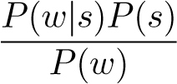*δMAP*(*w*) = argmax*P*(*s*|*w*) = argmax = argmax*P*(*w*|*s*)*P*(*s*) *s*∈*S s*∈*Ss*∈*S*

Fill in the table below

|  |  |  |  |  |  |  |
| --- | --- | --- | --- | --- | --- | --- |
| W | 0.94cm | 0.96cm | 0.98cm | 1.00cm | 1.02cm | 1.04cm |
| *P*(*S* = Good|*w*) | 0.988 | 0.988 | 0.952 | 0.909 | 0.333 | 0.50 |
| *P*(*S* = Bad|*w*) | 0.012 | 0.012 | 0.048 | 0.091 | 0.666 | 0.50 |
| *δMAP*(*w*) | Good | Good | Good | Good | Bad | Bad |

Table 3: Posterior Probability table and the MAP decision rule